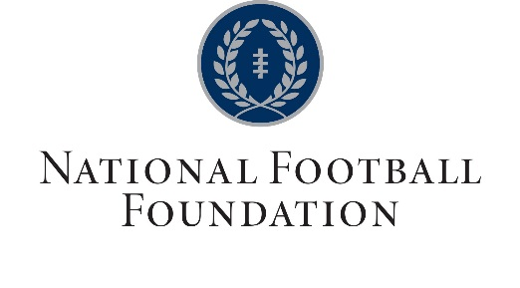
National Football Foundation – Iowa Chapter Scholar Athlete Award

This award recognizes a student athlete from the state of Iowa who excels in the classroom, community and on the field. Applications must be typed to be accepted. Criteria below are required to apply.

- Graduating senior football players only
- GPA must be 3.50 or higher
- ACT composite of 28 or higher
- Player must have been named to an All-District football team
- Applicants having held tangible leadership positions in school or community preferred

Name of School ____________________________________________ City ______________________

Class 8-man_____ A ____ 1A _____ 2A _____ 3A _____ 4A _____

Student Name ______________________________________________________

Home Address ________________________________________ City __________________ Zip _______

Email ___________________________________________

Parent/Guardian Name ___________________________________ Phone ____________________

Email ___________________________________________

1. Scholastic Standing: ACT score __________
GPA (4.0 scale) ________

Other Scholastic achievements and recognitions:

2. Leadership Roles/Activities/Clubs: (List leadership roles held at school or in your community)

3. Employment:

6. Athletic Participation: (sports you have participated in during high school and sports honors)

